Turbo Options for Cryptocurrencies
KHAN, Talha Hameed
CHANDREAN, Vittorio

- Introduction
The objective of this project is to explore the pricing and analysis of Turbo options on Bitcoin and Ethereum, leveraging both European and American styles. As the cryptocurrency market continues to evolve, innovative financial instruments like Turbo options present new opportunities for traders and investors.
To achieve this objective, we will utilize a rigorous methodology that includes the collection of historical price data from reputable sources, parameter estimation, and employment of tree-based discrete time pricing methods.
In addition to investigating pricing methods, we will conduct a comprehensive risk management analysis by computing the Greeks for both Bitcoin and Ethereum Turbo options. This analysis will help us understand the sensitivities of these options to changes in market conditions.
Finally, we will present an in-depth discussion on the advantages and disadvantages of Turbo options compared to vanilla options, justifying our analysis with numerical results. By addressing the potential risks associated with Bitcoin and Ethereum price jumps, we aim to evaluate the effectiveness of Turbo options as a hedging tool.
From our experiments, we found that the trinomial tree method (TTM) is more effective as a Turbo option pricing method due to its convergence and accuracy. The TTM also offers reasonable computational efficiency when compared to a simpler pricing method such as the binomial tree method (BTM). For the Turbo option alone, we found that it is characterized by high Delta for deep in-the-money options (e.g., 6.68 for BTC-USD calls at strike $81,665.46, 15 days maturity), amplifying leverage akin to futures, and elevated Gamma near the barrier (e.g., 0.139 for BTC-USD calls at strike 81,665.46, 45 days maturity), signaling rapid Delta shifts as the spot price nears the knock-out level. Vega is notably reduced (e.g., 4.93 for ETH-USD puts at strike 2,975.9, 180 days maturity) due to the barrier’s knock-out risk, limiting volatility exposure, while high Theta for short-term BTC-USD options (e.g., -124.67 daily decay at strike 105,484.56, 15 days) underscores their speculative appeal. Rho remains moderate (e.g., 90.62 for BTC-USD calls at strike 81,665.46, 45 days), reflecting low sensitivity to interest rate changes in crypto markets. Due to its characteristics, we also think that both trading platforms and investors benefit from the launching of Turbo options for cryptocurrencies, as they can be used as leverage or hedging tools for investors, and platforms to gain attraction from investors by launching an option with unique characteristics that can be versatile for investors.

- Methodology
- Data Collection
As we use Python to conduct our analysis, we extracted historical BTC-USD and ETH-USD prices from the Yahoo Finance API.
- Parameter Estimation
The pricing methods require a standard deviation estimate to calibrate key input parameters. This estimate is derived from the annualized historical volatility calculated using the sample standard deviation of logarithmic returns of asset closing prices, where returns are defined as the natural log of the ratio of consecutive prices. Using the sample standard deviation implies an assumption that the returns are normally distributed. The daily standard deviation is annualized by multiplying by the square root of 365.25 trading days per year, reflecting continuous cryptocurrency trading. A minimum of five valid return observations is necessary for a reliable estimate; otherwise, a fallback volatility of 50% is used. Additionally, the volatility is constrained between 10% and 200% to ensure realistic values. The quality of this estimate depends on the chosen lookback period for historical data, which is critical but external to the calculation method. Lastly, we also assume that interest rates are continuously compounded.
The estimated standard deviation is then used to calculate the binomial tree parameters: the up factor (u) and down factor (d), which define the possible price movements per time step, as well as the risk-neutral probability (p) of an upward price movement.
Below are the formulas for estimating the movement factors and the risk neutral probability:
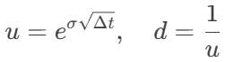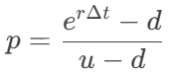

- Pricing Methods
We used 2 discrete pricing methods for this study, which are the binomial tree and the trinomial tree method. We will also consider all possible scenarios for both tree-based methods, including European and American style barrier options. The model is built on several key assumptions to facilitate the pricing methods. It assumes that the volatility of the underlying asset remains constant over the option’s lifetime, ensuring stable risk estimates. Similarly, the risk-free interest rate is considered constant throughout the option’s duration, simplifying discounting of future payoffs. Additionally, the model presumes a no-arbitrage market environment, which is fundamental for applying risk-neutral valuation techniques and ensuring that there are no opportunities for riskless profit. These assumptions provide a theoretical framework that enables consistent and tractable option pricing.
- Numerical Experiments
We will conduct numerical experiments using the 2 pricing methods through changing input parameters.
- Performance Analysis
The performance of the two methods will be compared in terms of convergence and computing efficiency. Specifically, we will be testing convergence in terms of tree periods (steps) and computing runtime.
- Out-In Parity
In theory, the payoff of a knock-in option combined with a knock-out option is equivalent to that of a vanilla option, a relationship known as the in-out parity. This principle will be employed to verify the accuracy and convergence of our pricing models. We will compare the sum of knock-in and knock-out option prices against synthetic vanilla option prices generated within the model.

- Numerical Experiments for Turbo Option Pricing Methods
Numerical experiments are conducted on down-and-out call barrier options.
- Binomial Tree Method (BTM) for European style barrier options
Varying barriers (barrier_pct: setting barrier price as a % of current_price):
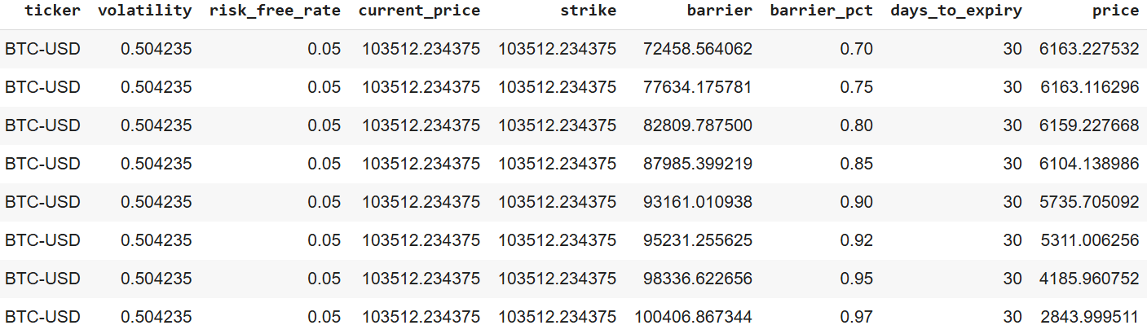
Varying strikes (strike_pct: setting strike price as a % of current_price):
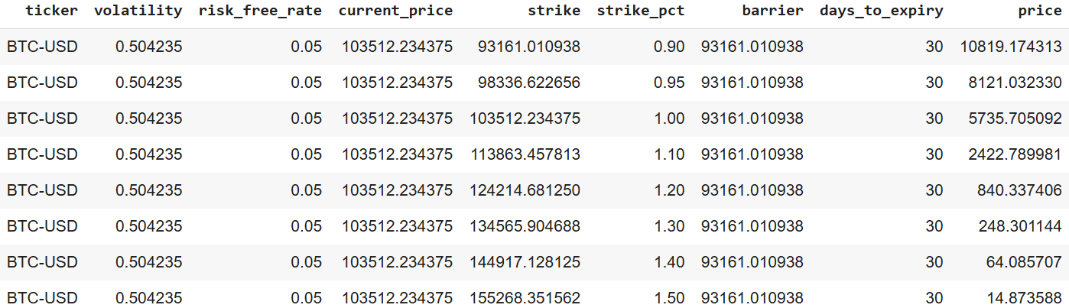
Varying BTM periods:
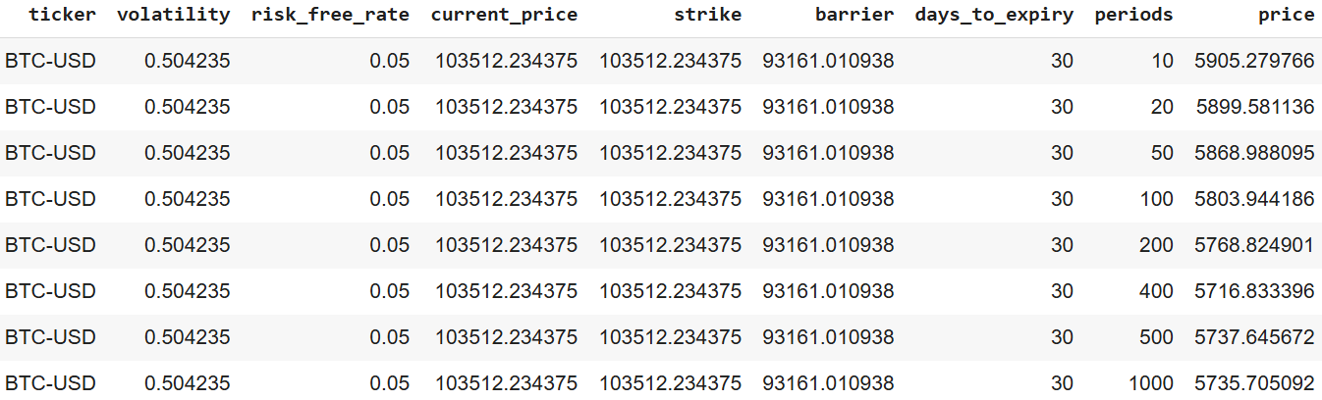
Varying time to maturities:
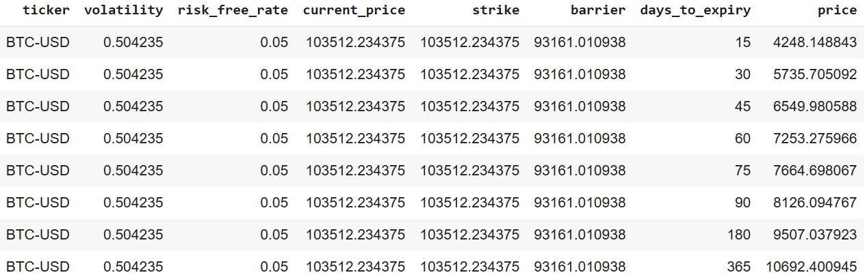

- Trinomial Tree Method (TTM) for European style barrier options
Varying barriers (barrier_pct: setting barrier price as a % of current_price):
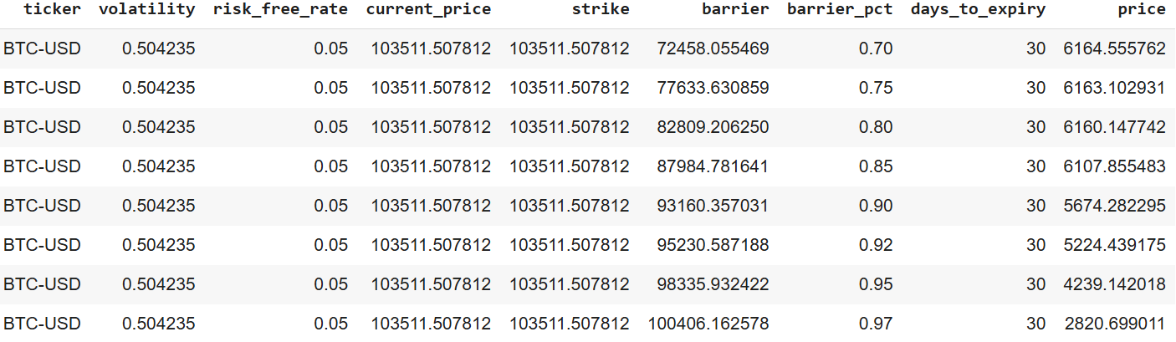
Varying strikes (strike_pct: setting strike price as a % of current_price):
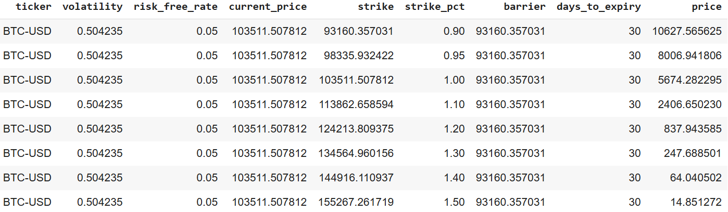
Varying TTM periods:
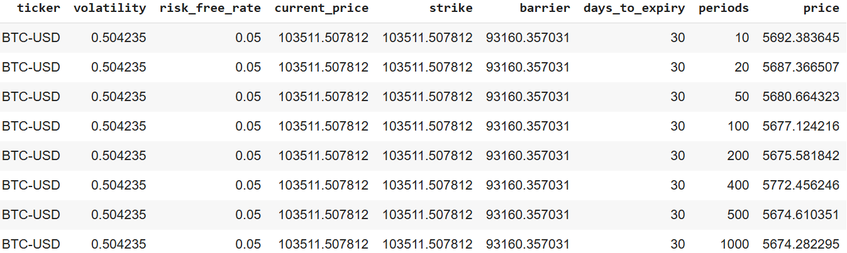
Varying time to maturities:
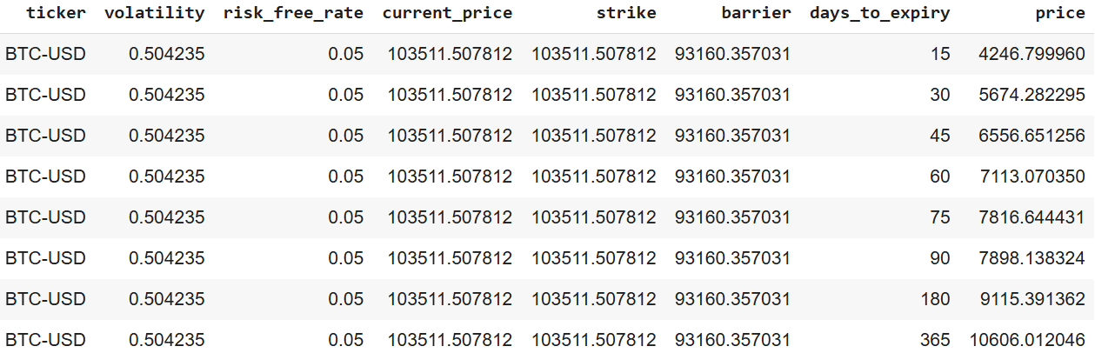

- Binomial Tree Method (BTM) for American style barrier options
Varying barriers (barrier_pct: setting barrier price as a % of current_price):
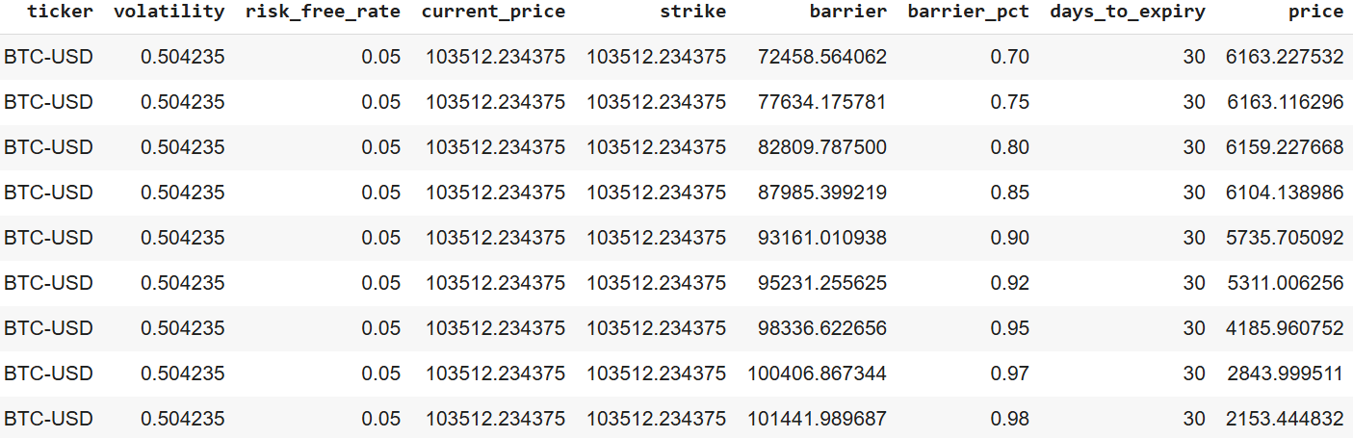
Varying strikes (strike_pct: setting strike price as a % of current_price):
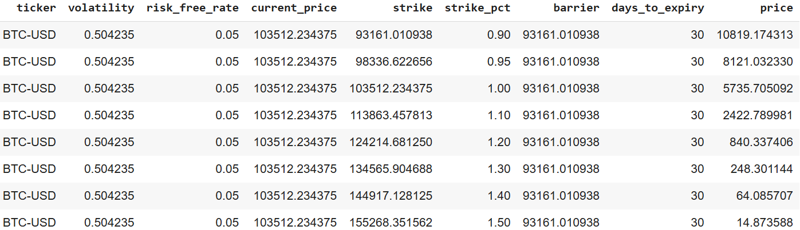
Varying BTM periods:
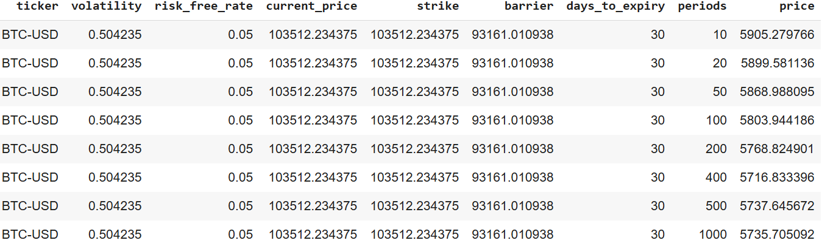
Varying time to maturities:
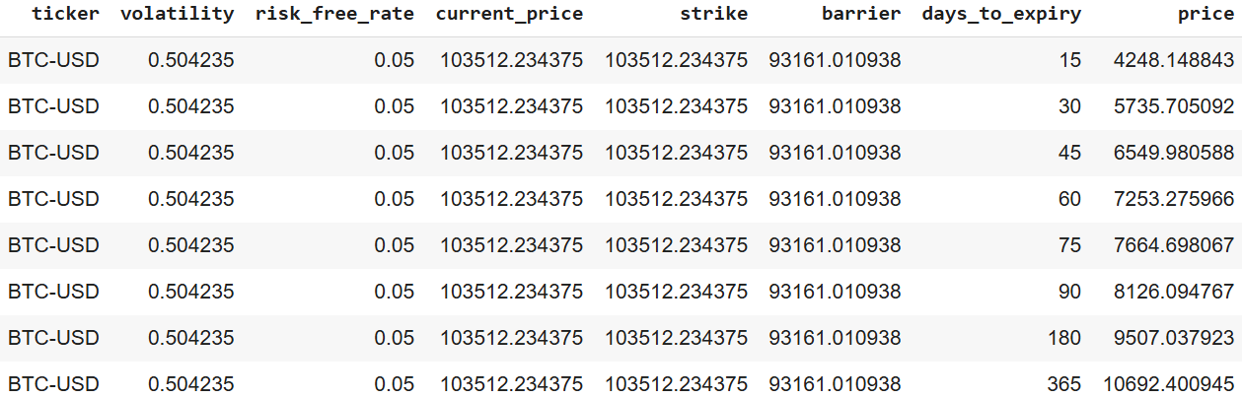

- Trinomial Tree Method (TTM) for American style barrier options
Varying barriers (barrier_pct: setting barrier price as a % of current_price):
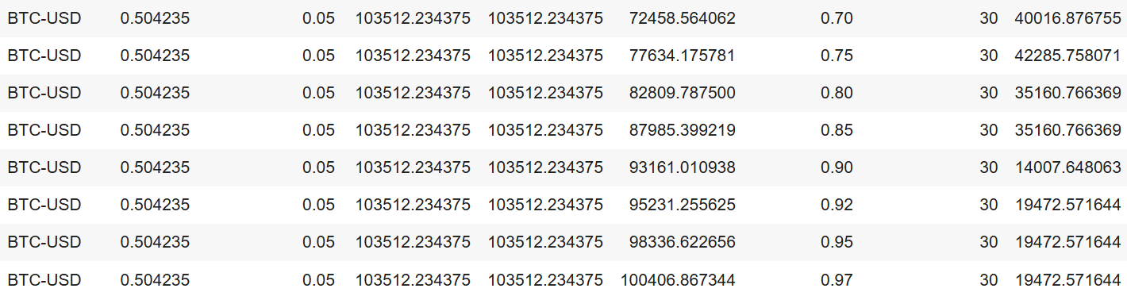
Varying strikes (strike_pct: setting strike price as a % of current_price):
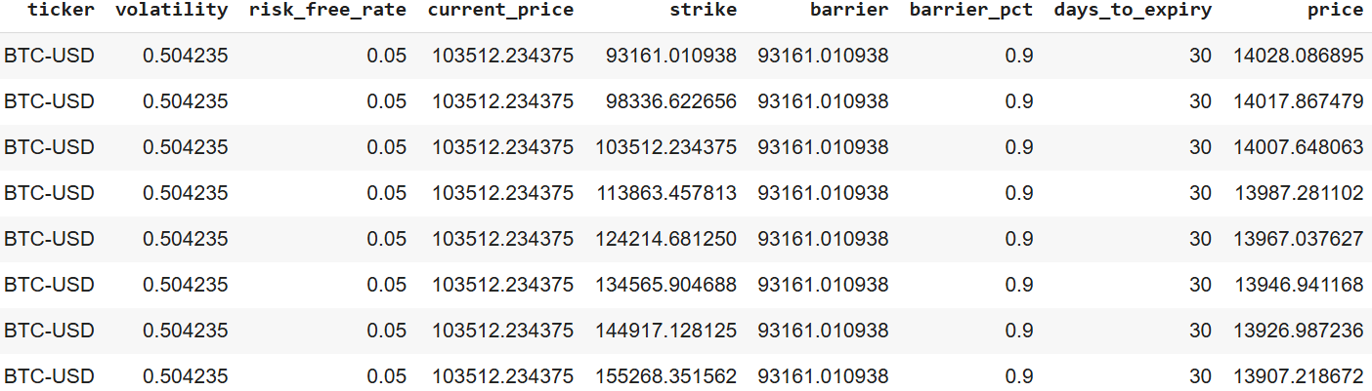
Varying BTM periods:
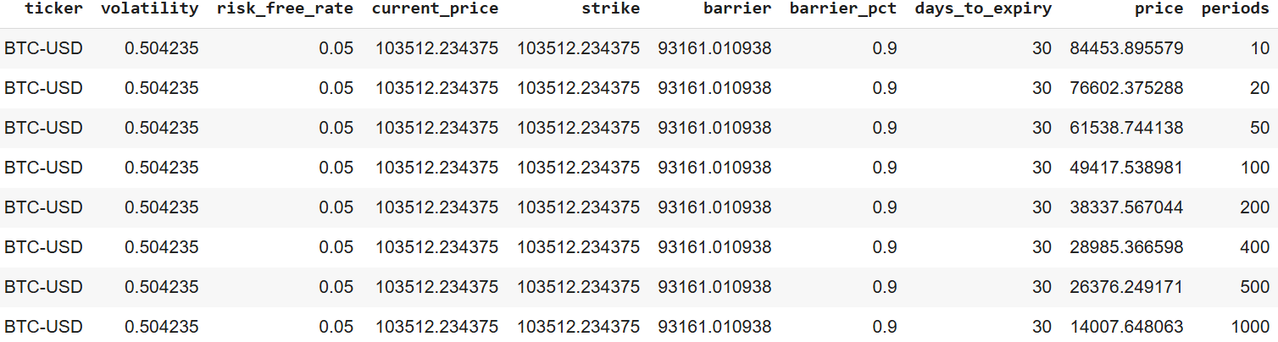
Varying time to maturities:
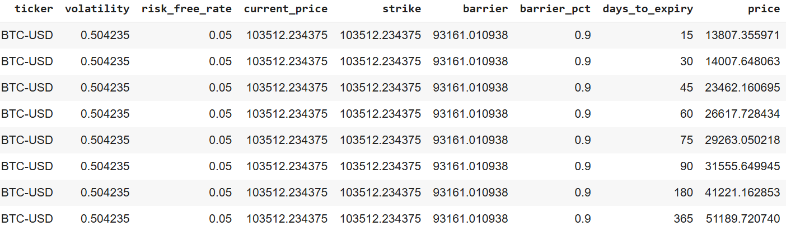

- Convergence Test Results
Parameters:
- Option type: down-and-out call
- Spot price = strike price = 104106.36
- 45 days to maturity
- 5% interest rate
- Volatility = 0.42
- Barrier = 0.8 * 104106.36
European style down-and-out call prices over different tree periods:
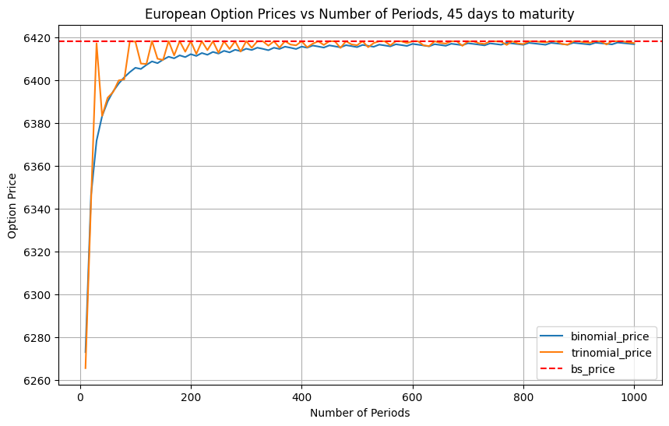
American style down-and-out call prices over different tree periods:
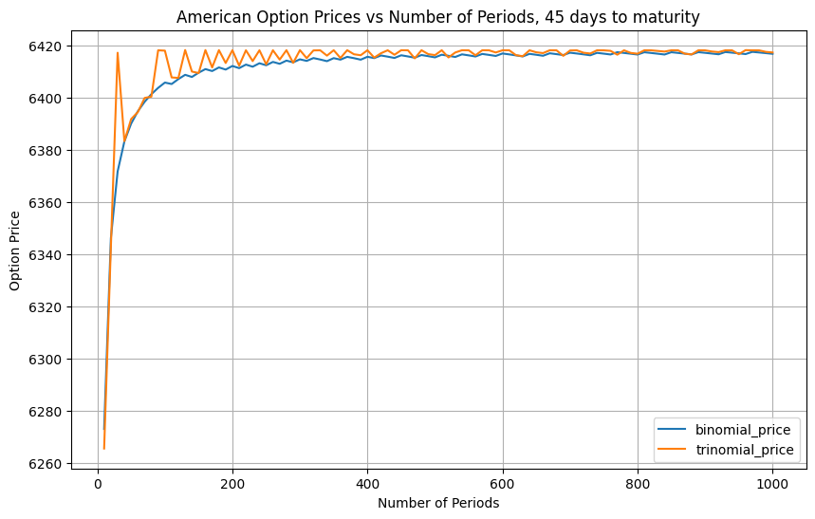

- Computing Efficiency
The computation runtimes are taken from the convergence experiments (section IV).
European style computation runtimes:
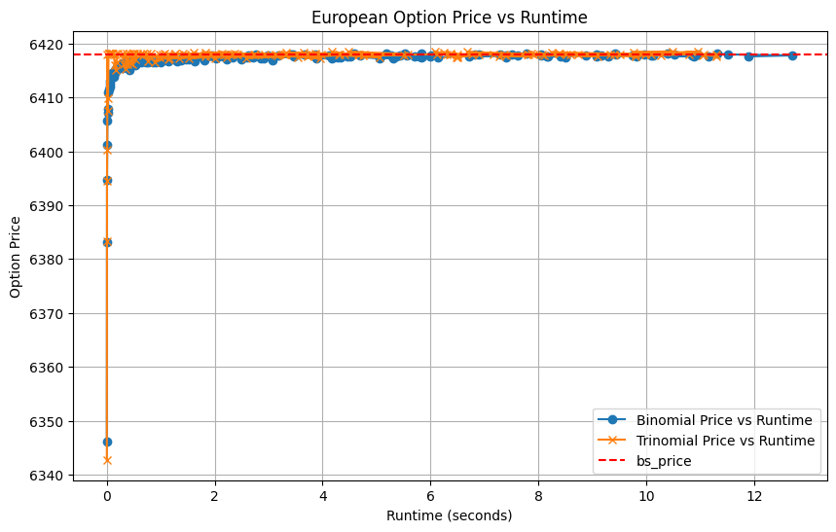
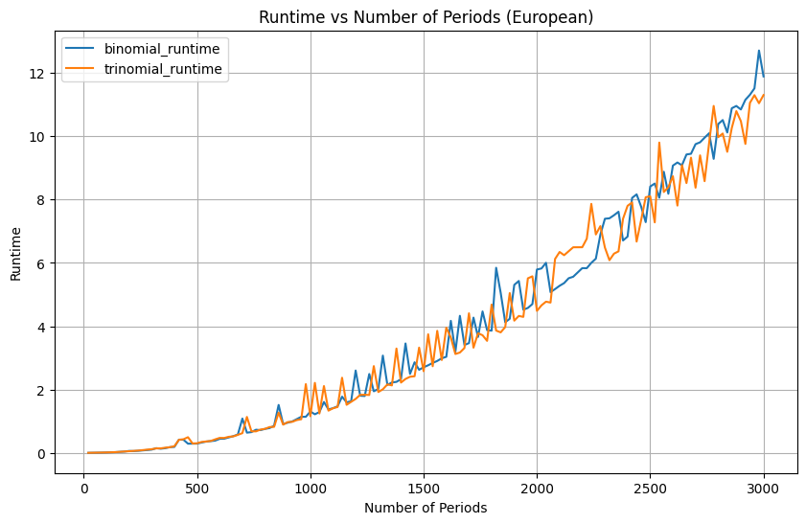
American style computation runtimes:
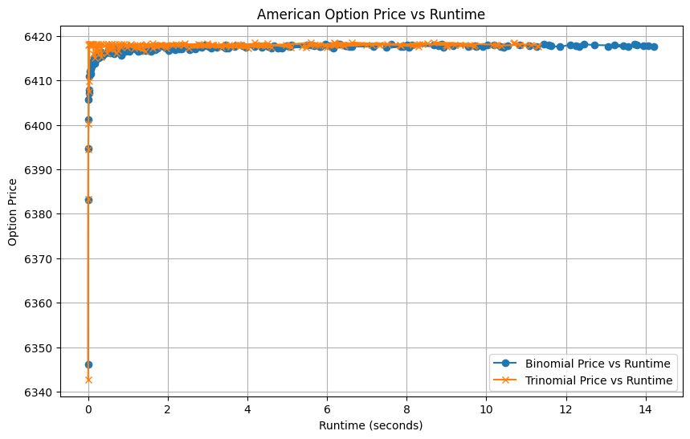
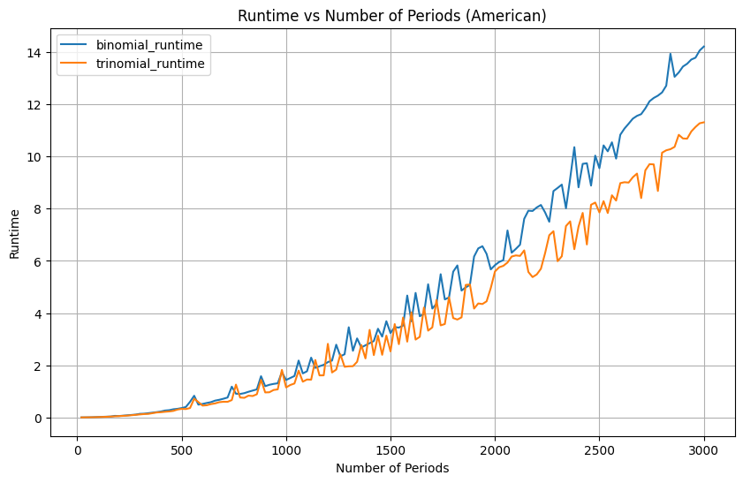

- Out-In Parity
Base parameters are similar to the convergence test, with the option type being downstream European call options and 1000 periods for the tree methods. We only conducted out-in parity experiments on European style barrier options because the out-in parity holds exactly for this type, but may not hold for American style barrier options due to their early-exercise characteristic.
Parity results using TTM:
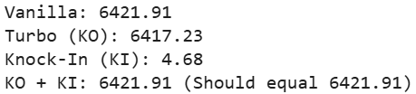
Parity results using BTM:
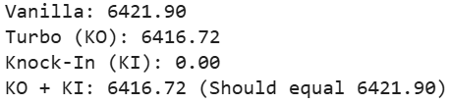

- Pricing Method Analysis
Based on our experiments with both American and European style barrier options, the trinomial tree method (TTM) demonstrates superior accuracy compared to the binomial tree method (BTM). The TTM converges more quickly to the solution derived from the Black-Scholes framework and can price barrier options with sufficient precision to satisfy the out-in parity. This improved accuracy is largely due to the additional mid-price movement incorporated in the TTM, which allows for a more refined approximation of the underlying asset’s price dynamics. By considering three possible price movements at each step-up, down, or unchanged-the TTM reduces pricing bias and better enforces barrier conditions. In contrast, the BTM only considers two price movements per step, which can lead to less precise barrier detection and slower convergence.
While the BTM theoretically requires fewer computations because it calculates a total of 2^{n} nodes compared to the TTM’s 3^{n} nodes, this advantage holds only up to a certain point for European barrier options and is generally not true for American-style barrier options. The difference in runtime performance between the two methods can also be attributed to structural differences in their implementation. Our BTM function was designed to be more general and flexible, requiring additional input parameters and logic checks to handle various option types, which introduces computational overhead. On the other hand, the TTM implementation was more specialized and streamlined, with specific functions built for different option types, resulting in more direct task handling and better runtime efficiency despite the larger number of nodes.
Considering the strengths and weaknesses of each method, the TTM is more suitable when accuracy and faster convergence are priorities, especially for pricing barrier options with fewer time steps. Its additional middle branch enables a finer approximation of price movements, which is particularly beneficial for complex barrier structures and for ensuring theoretical properties like in-out parity. Conversely, the BTM is preferable when computational efficiency is the primary concern, such as in real-time pricing or scenarios requiring a large number of valuations. Although the BTM may require more time steps to reach comparable accuracy, its simpler two-branch structure results in lower computational cost per step. Therefore, the TTM is favored for accuracy and convergence speed in barrier option pricing, while the BTM is advantageous for its computational speed and simplicity when resources or time are limited.

- Risk Management Analysis
The introduction of Turbo options on cryptocurrencies like Bitcoin (BTC-USD) and Ethereum (ETH-USD) presents unique risk management challenges and opportunities for traders and platforms. Unlike vanilla options, the defining feature of a Turbo option—its knockout barrier—fundamentally alters the behavior of its risk sensitivities, commonly known as "the Greeks." This section evaluates these Greeks (Delta, Gamma, Vega, Theta, and Rho) for BTC-USD and ETH-USD Turbo options, highlighting their distinct characteristics, comparing across assets and option styles (European vs. American), and discussing implications for hedging strategies, particularly concerning the jump risk prevalent in cryptocurrency markets.
The presence of a knockout barrier means that the Greeks of Turbo options do not always behave in line with their vanilla counterparts, especially as the underlying asset's price approaches the barrier or as the option nears expiry.

1. Delta (Δ): Rate of Change of Option Price
Delta measures the sensitivity of an option's price to a one-unit change in the price of the underlying asset. A salient feature observed is that Turbo option Deltas can extend beyond the typical [0,1] range for calls and [-1,0] for puts. This suggests that these Turbo options can behave like leveraged instruments. For instance, our findings show BTC-USD call Deltas sometimes exceeding 1.0 and ETH-USD put Deltas falling below -1.0, particularly for 30-day European Turbo options.
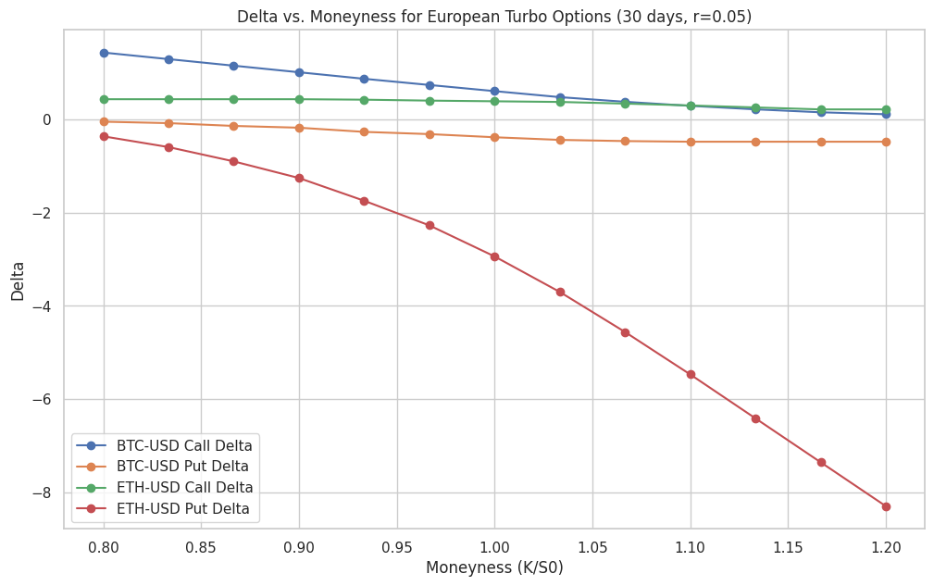
This graph illustrates that for 30-day European Turbo calls, BTC-USD Delta starts high for ITM options (low K/S0) and declines. Conversely, ETH-USD Put Delta becomes increasingly negative as the put goes deeper ITM (high K/S0), signifying a behavior akin to a highly leveraged short position in the underlying. ETH-USD calls and BTC-USD puts show more subdued Delta values across the moneyness spectrum in this specific configuration. Further analysis indicates that for At-The-Money (ATM) European Turbo options, Delta can exhibit considerable instability and occasionally reach extreme values at certain maturities. This suggests that the directional risk of Turbo options can change in complex ways as time passes, necessitating active management of hedge ratios.
The choice of option style significantly impacts Delta. When comparing 90-day BTC-USD Turbo Puts, the American style demonstrates a markedly different Delta profile as it moves deeper in-the-money.
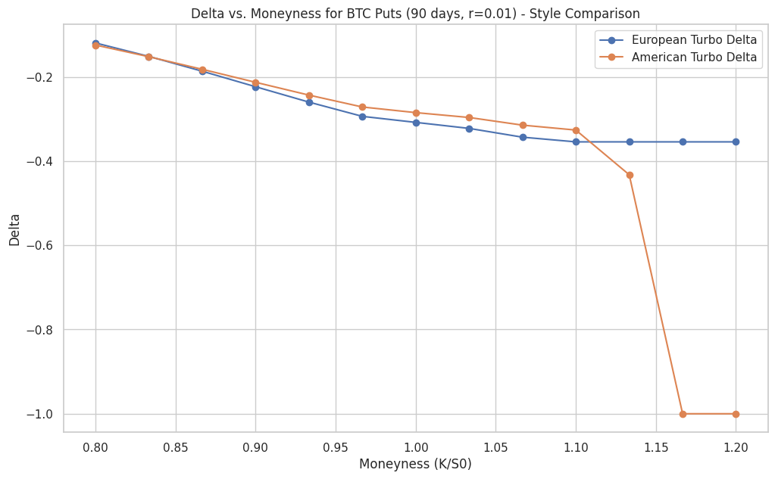
As illustrated, the American Turbo Put's Delta shifts rapidly towards -1.0 once sufficiently ITM (around K/S0 = 1.15). This reflects the early exercise feature, allowing holders to effectively take a full short position in the underlying. The European style, without this feature, shows a more constrained Delta.
2. Gamma (Γ): Sensitivity of Delta
Gamma measures how Delta itself changes with the underlying asset's price. It is crucial for assessing hedge stability. A key finding is that Gamma can reach extreme levels for Turbo options, especially if the underlying asset's price is near the knockout barrier. High Gamma implies that Delta is very sensitive, necessitating frequent and potentially costly hedge adjustments.
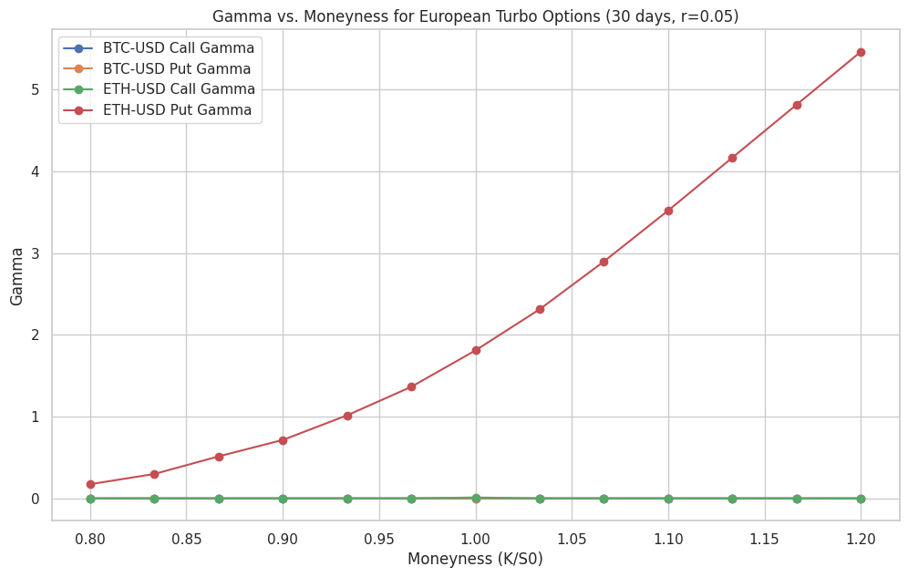
This graph highlights a dramatic increase in Gamma for 30-day European Turbo ETH-USD Puts as they move deeper in-the-money (higher K/S0), indicating significant instability in their Delta. In contrast, other options in this view show flatter Gamma. The analysis of ATM options across different maturities also revealed periods of exceptionally high (and sometimes negative) Gamma, underscoring the complex hedging environment for Turbo options.
The Gamma profiles for American and European style BTC Turbo Puts also differ.
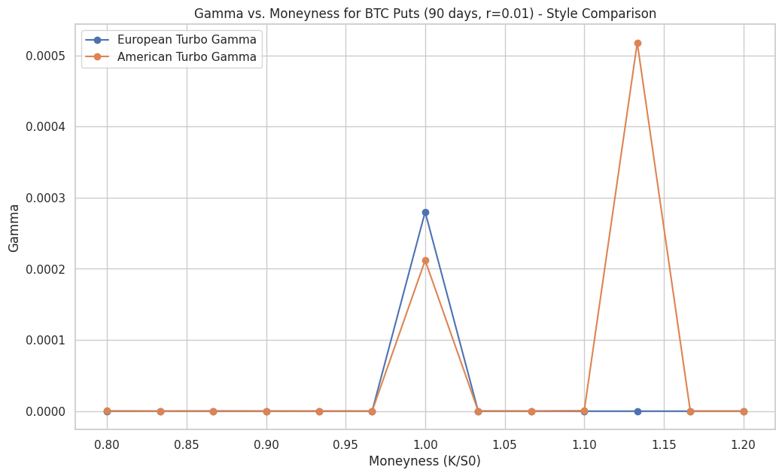
The American Turbo Put exhibits a distinct and very sharp Gamma spike when deep in-the-money (around K/S0 = 1.125), a feature not mirrored by the European style at that same moneyness. This spike indicates a highly volatile Delta for the American option around that point, likely related to the optimal early exercise decision. Both styles show some Gamma elevation closer to at-the-money.
3. Vega (V): Sensitivity to Volatility
Vega quantifies sensitivity to changes in the underlying asset's implied volatility.
Turbo options generally exhibit different Vega characteristics than vanilla options. The presence of a barrier can dampen Vega, as increased volatility might also increase the chance of a knockout, offsetting the usual positive impact of higher volatility on option value
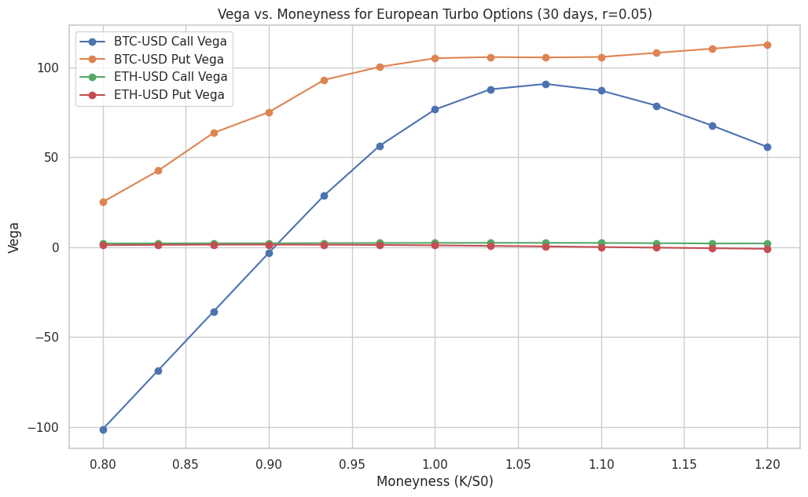

The graph shows that for 30-day European Turbos, ETH-USD options have very low Vega. BTC-USD calls, however, display a more pronounced Vega profile, including negative Vega when deep in-the-money. Negative Vega, where an option's value decreases with rising volatility, is a known feature of some barrier options when the knockout risk becomes dominant. Our findings also indicate that Vega for ATM Turbo options varies considerably with time to maturity.
For BTC Puts, American style options tend to have higher Vega than European ones when OTM and ATM. However, as the American Turbo Put moves deep in-the-money, its Vega sharply declines towards zero.
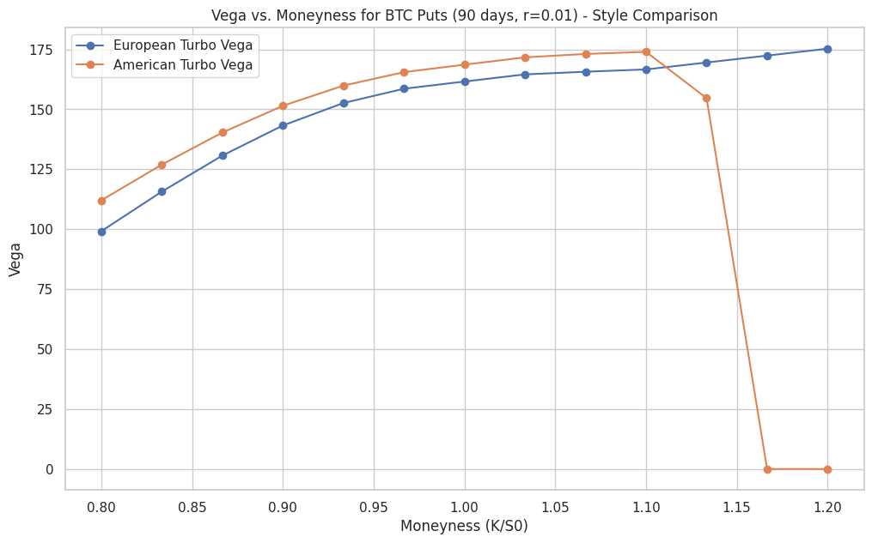
This drop is logical, as the option becomes a near certainty for early exercise, making its value less sensitive to future volatility.
4. Theta (Θ): Sensitivity to Time Decay
Theta measures the rate of an option's value decline as time passes. The rate of time decay for Turbo options is significantly influenced by the barrier.
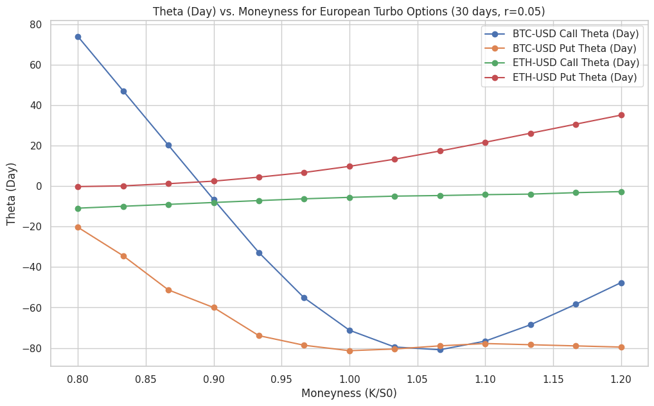
For 30-day European Turbos, options that are OTM (like BTC-USD calls at high K/S0 or BTC-USD puts at low K/S0) show substantial negative Theta, meaning their value erodes quickly. The study of Theta across different maturities for ATM options also revealed periods of accelerated or even positive Theta for certain configurations, which highlights complex interactions between time passage, barrier proximity, and option value.
American Turbo BTC Puts generally show a more pronounced time decay (more negative Theta) than their European counterparts when OTM and ATM. However, when deep in-the-money, the American option's Theta approaches zero.
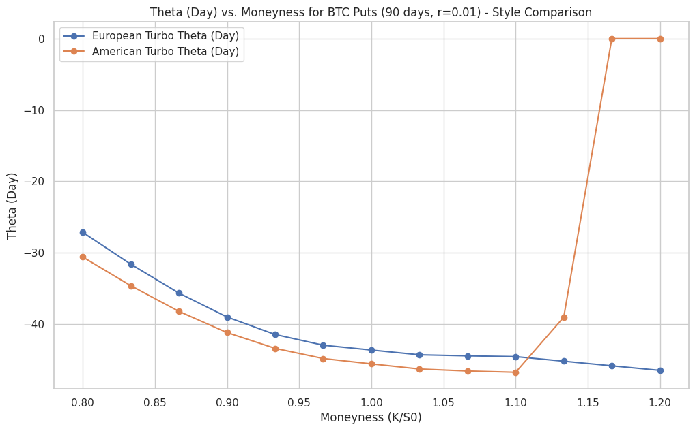
Once early exercise is optimal and imminent, the passage of additional small units of time has little impact on the option's value.
5. Rho (ρ): Sensitivity to Interest Rates
Rho measures sensitivity to changes in the risk-free interest rate. Consistent with many short-dated options, and particularly relevant in the context of cryptocurrency markets where interest rate sensitivity is often overshadowed by volatility, Rho appears to have a relatively minor impact on the studied Turbo option prices.
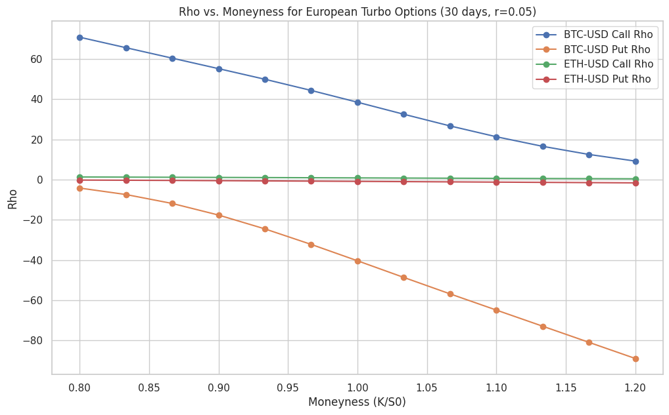
The graph indicates that for 30-day European Turbos, ETH-USD options have negligible Rho. BTC-USD options show the expected positive Rho for calls and negative Rho for puts, with magnitudes decreasing for OTM options. This suggests interest rate risk is a lesser concern in managing these instruments.

Hedging Jump Risk with Turbo Options
A critical application for Turbo options in the volatile cryptocurrency markets is their potential to mitigate jump risk, as per Question 8 of the project guidelines. The knockout barrier inherent in Turbo options provides a natural defense against sudden, large, adverse price movements.
If a price jump breaches the barrier, the Turbo option is automatically knocked out, typically expiring worthless (or with a pre-defined rebate). This feature acts as an embedded stop-loss, clearly defining the maximum risk associated with the option position itself. This contrasts sharply with vanilla options, where losses could continue to mount if the underlying price moves further after a jump.
Turbo options are generally priced lower than otherwise equivalent vanilla options due to the risk of knockout. This lower premium makes them a more capital-efficient tool for hedging against tail events or significant price jumps.
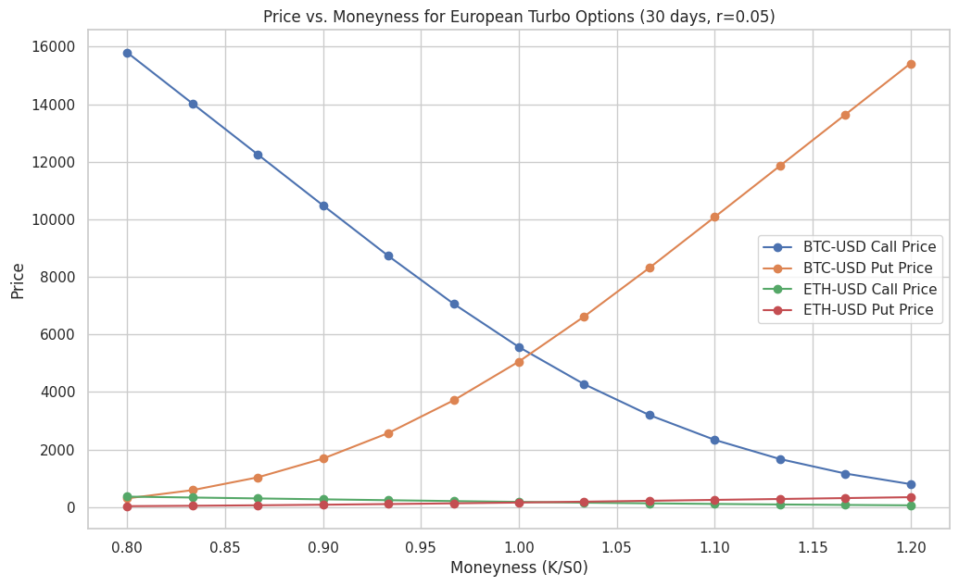
Challenges in Hedging with or Against Turbo Options
While offering benefits like jump protection, the unique Greek profiles of Turbo options introduce hedging complexities:
- Gamma Risk Management: The potential for extremely high Gamma, especially near the barrier, makes traditional delta hedging challenging. Frequent rebalancing may be necessary, incurring higher transaction costs. A sudden jump over the barrier could also leave a delta hedge imperfect.
- Vega Dynamics: The non-standard Vega behavior, including instances of negative Vega, requires careful consideration for volatility hedging strategies.
- Barrier Proximity: The primary driver of Turbo option risk is often its proximity to the barrier. The closer the spot price to the barrier, the higher the likelihood of a knockout and the more sensitive the Greeks can become. Our analysis regarding the impact of varying barrier levels (Barrier-to-Spot ratio) for ATM options indicates that Greeks are indeed highly sensitive to barrier placement, reinforcing the need for careful barrier selection.

Risk Management Strategies: Key Considerations
Effective risk management of Turbo options involves:
- Understanding Leverage: Recognizing that Turbo options can offer high leverage (Delta > 1 or < -1) is crucial for position sizing.
- Active Delta Hedging: Due to potentially volatile Delta and high Gamma, delta hedges need to be monitored and adjusted more actively than for simpler options.
- Gamma Awareness: Traders should be acutely aware of the Gamma profile. Strategies might involve avoiding positions where Gamma is excessively high if stability is desired, or specifically trading Gamma if anticipating certain price movements relative to the barrier.
- Barrier Selection: The choice of barrier level is a critical risk management decision, balancing the cost of the option against the desired protection and the probability of knockout.
- Style Suitability: The distinct risk profiles of European versus American Turbo options (particularly evident in the BTC Put comparisons) mean that the choice of style should align with the trader's objectives and risk tolerance. American options offer flexibility but introduce complexities related to optimal early exercise.

- Discussions
Turbo options are a type of exotic option that combine vanilla call or put options with a knockout barrier, creating a unique risk-return profile. Unlike vanilla options, which have fixed expiry dates, Turbo options expire immediately if the underlying asset’s price touches or crosses a predetermined knockout barrier. This early expiry risk lowers the option’s price and increases its inherent leverage, making Turbo options attractive for traders seeking leveraged exposure with built-in stop-loss mechanisms.
Delta Exchange, a leading crypto derivatives platform, launched Turbo options for Bitcoin with a knockout barrier set very close to the spot price (e.g., 0.5% below spot). These options are always deep in the money, meaning their delta is close to 1, and they behave similarly to leveraged futures positions but with a fixed stop-loss at the knockout barrier. The leverage of Turbo options is directly linked to the proximity of the spot price to the barrier: the closer the spot to the barrier, the higher the knockout risk, the lower the option price, and the greater the effective leverage. At launch, leverage on these options can reach up to 200x.
From a platform perspective, offering Turbo options can significantly benefit exchanges like Deribit or Delta Exchange. Turbo options attract new user segments interested in leveraged, risk-managed products, thereby increasing trading volumes and generating higher fee revenues. Additionally, providing innovative derivatives enhances the platform’s competitive positioning and reputation for catering to sophisticated trader demands.
Numerical analyses and pricing experiments further highlight the advantages of Turbo options. For example, the discount of a Deep In-The-Money Turbo Call relative to a vanilla call grows as time to expiry increases. With very short expiries, the knockout risk is low, so the discount is small. As expiry lengthens, the probability of hitting the barrier rises, increasing the discount and making the Turbo option relatively cheaper.

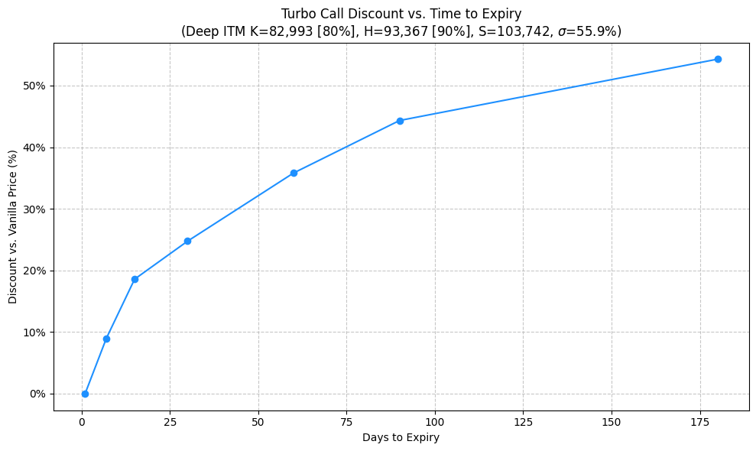
Similarly, the proximity of the barrier to the spot price significantly influences the Turbo option’s discount. For a 30-day Deep ITM Turbo Call, when the barrier is set far below the spot price (a low barrier-to-spot ratio), the knockout risk is minimal, and the discount remains small. However, as the barrier moves closer to the spot price, the knockout risk rises sharply, causing a substantial increase in the discount. This feature allows investors to select barrier levels that align with their desired balance between cost and risk exposure.
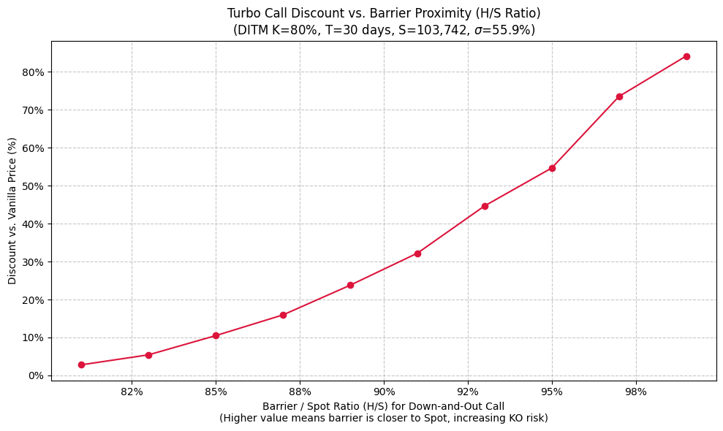
Supporting these findings, a heatmap visualization shows how Turbo option values vary systematically with both barrier level and time to expiry. The heatmap reveals that Turbo option values decline significantly as the barrier moves closer to the spot price, especially for longer maturities, reflecting the increased knockout risk. For short-dated options, value differences across barriers are less pronounced, consistent with the limited time for barrier breaches.
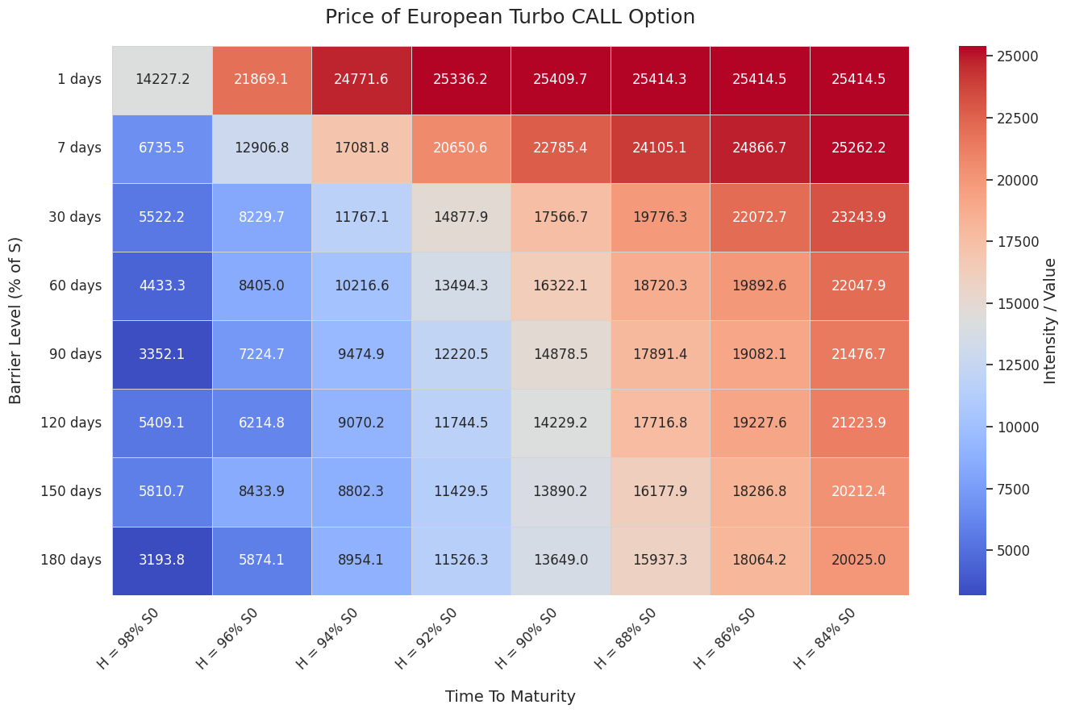
For platforms like Deribit, which currently offer only vanilla European options on Bitcoin and Ethereum, launching Turbo options represents an opportunity to expand their product suite and capture greater market share. By providing traders with more sophisticated instruments that offer cost advantages and tailored risk profiles, Deribit can attract a broader user base, increase trading activity, and enhance revenue streams through fees and spreads. Furthermore, offering Turbo options positions Deribit as an innovative leader in the crypto derivatives space, potentially setting it apart from competitors.
From an investor’s perspective, Turbo options-being a type of barrier option with embedded knockout features-offer a powerful and efficient way to hedge against the frequent and often sharp price jumps seen in Bitcoin and Ethereum markets. Unlike vanilla options, Turbo options automatically expire worthless if the underlying asset’s price hits a predetermined barrier, effectively limiting downside risk by cutting losses early. This built-in knockout mechanism acts like an automatic stop-loss, helping investors manage sudden adverse price movements without needing to actively monitor or adjust their positions.
From an investor’s perspective, Turbo options—being a type of barrier option with embedded knockout features—offer a powerful and efficient way to hedge against the frequent and often sharp price jumps seen in Bitcoin and Ethereum markets. For instance, an ETH-USD Turbo put (strike 3,060.93, 180 days maturity, barrier 2,805.85) has a high Delta of -0.999, ensuring strong protection against price drops, with a low price of 510.15 USD due to the barrier’s knock-out risk. Similarly, a BTC-USD Turbo call (strike 81,665.46, 15 days maturity, barrier 91,873.645) exhibits a Delta of 6.68 and price of 17,245.61 USD, offering leveraged exposure with automatic risk limitation. The reduced Vega (e.g., 4.93 for ETH-USD puts at strike 2,975.9) and high Theta (e.g., -124.67 for BTC-USD calls at strike 105,484.56) further tailor Turbo options for jump-prone markets, balancing cost and risk. Unlike vanilla options, Turbo options automatically expire worthless if the underlying asset’s price hits a predetermined barrier, effectively limiting downside risk by cutting losses early. This built-in knockout mechanism acts like an automatic stop-loss, helping investors manage sudden adverse price movements without needing to actively monitor or adjust their positions.
Because cryptocurrency prices are prone to large jumps and heightened volatility, traditional hedging tools sometimes fall short in containing extreme downside risk efficiently. Turbo options address this gap by combining leveraged exposure with a clearly defined risk boundary. Investors can customize the barrier level to balance the cost of the option against their tolerance for knockout risk, enabling a tailored hedging strategy that dynamically responds to market conditions.
Moreover, the path-dependent nature of Turbo options means they are particularly well-suited to environments with jump risks. The knockout barrier ensures that once a significant adverse price move occurs, the option terminates, preventing further losses beyond the barrier level. This feature can reduce the impact of sudden market shocks on an investor’s portfolio more effectively than vanilla options, which remain alive regardless of intermediate price jumps.

